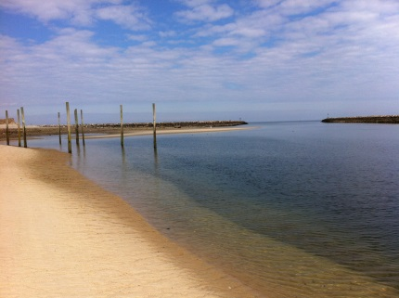

Owner(s) _________________________________________________________

Property Address ___________________________________________________

Lot Number (if known) _________________ Year of Purchase ____________

Mail (if different from permanent address, PO Box etc.) _____________________

_________________________________________________________________

Phone *Home _______________________ *Cell ______________________

Emergency Number ______________________

Email Address _____________________________________________________

Immediate family names and ages _____________________________________

_________________________________________________________________

By signing below, I acknowledge that I have read the PWA rules and regulations which are posted on the PWA web page - (go to the site, then click on “Newsletters”, then the most current), and will abide by them. I understand that it is my responsibility to inform my family members, guests, and renters of such rules.

Signature __________________________________________ Date______________

Annual dues of $300 (no cash please) are to be made out to PWA and sent together with this application to Paul Maher, Vice President.